CYBER SECURITY LAB REPORT
Day 15: Controlled Penetration Testing Lab
Day 16: Risk Assessment

Student Name: Urooj
Lab Environment: Kali Linux (Attacker - 192.168.56.104) & Metasploitable 2 (Victim - 192.168.56.102)
Network Mode: Host-Only Adapter (Isolated Lab)

1. Executive Summary
This lab was performed in a fully controlled and isolated environment. The objective was to understand the attack chain methodology without causing any harm to real networks. All activities were limited to reconnaissance and version detection.

2. Attack Chain Methodology
The attack chain followed five phases:
Reconnaissance -> Discovery & Enumeration -> Vulnerability Identification -> Controlled Validation -> Impact & Mitigation
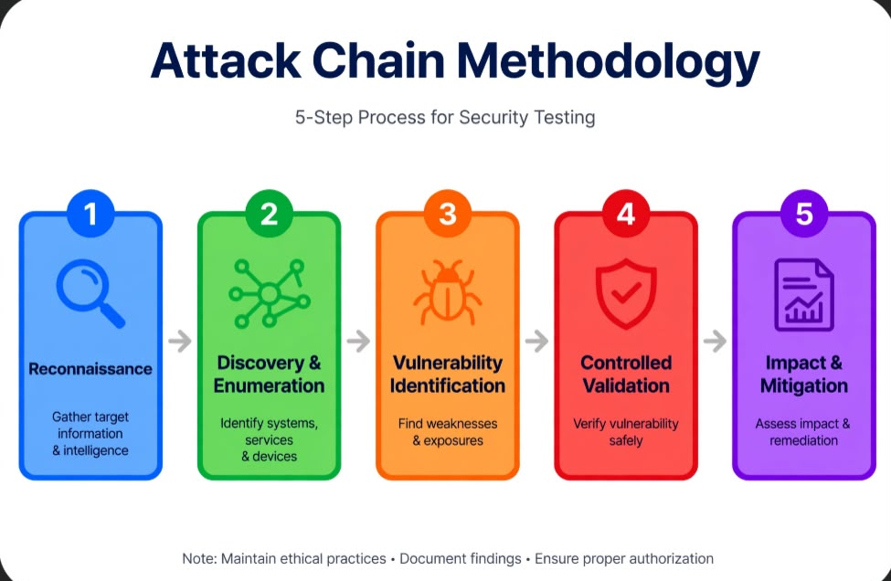
3. Phase 1: Reconnaissance
Command Used: `ifconfig`
Result: Attacker machine IP was confirmed as 192.168.56.104/24. This confirms the lab is isolated in Host-Only mode.
Evidence: [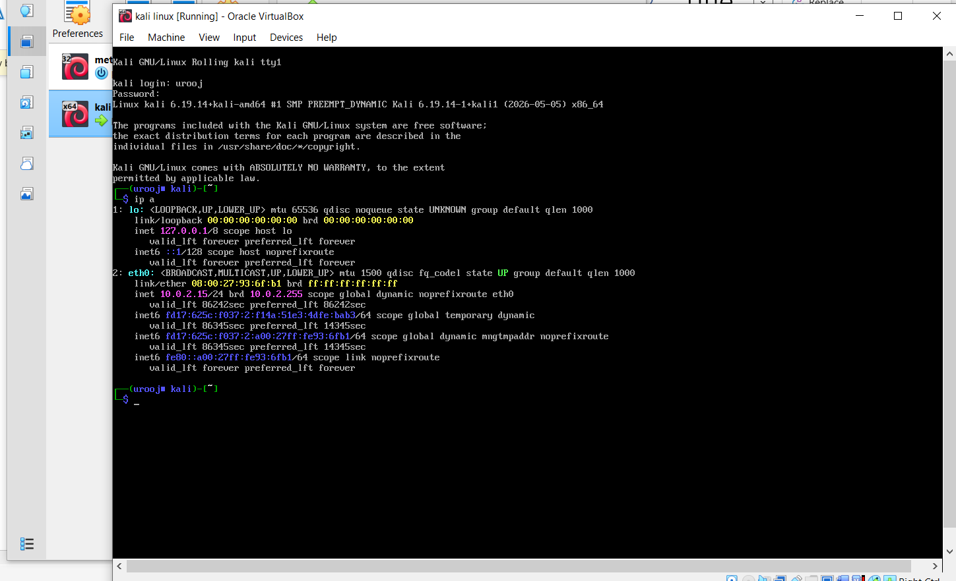

4. Phase 2: Discovery & Enumeration
Command Used: `nmap -sV 192.168.56.102`
Result: Victim machine was discovered at 192.168.56.102. Multiple open ports and services were found:
- 21/tcp open ftp vsftpd 2.3.4
- 22/tcp open ssh OpenSSH 4.7
- 80/tcp open http Apache Tomcat
- 3306/tcp open mysql
- 5432/tcp open postgresql
Evidence: [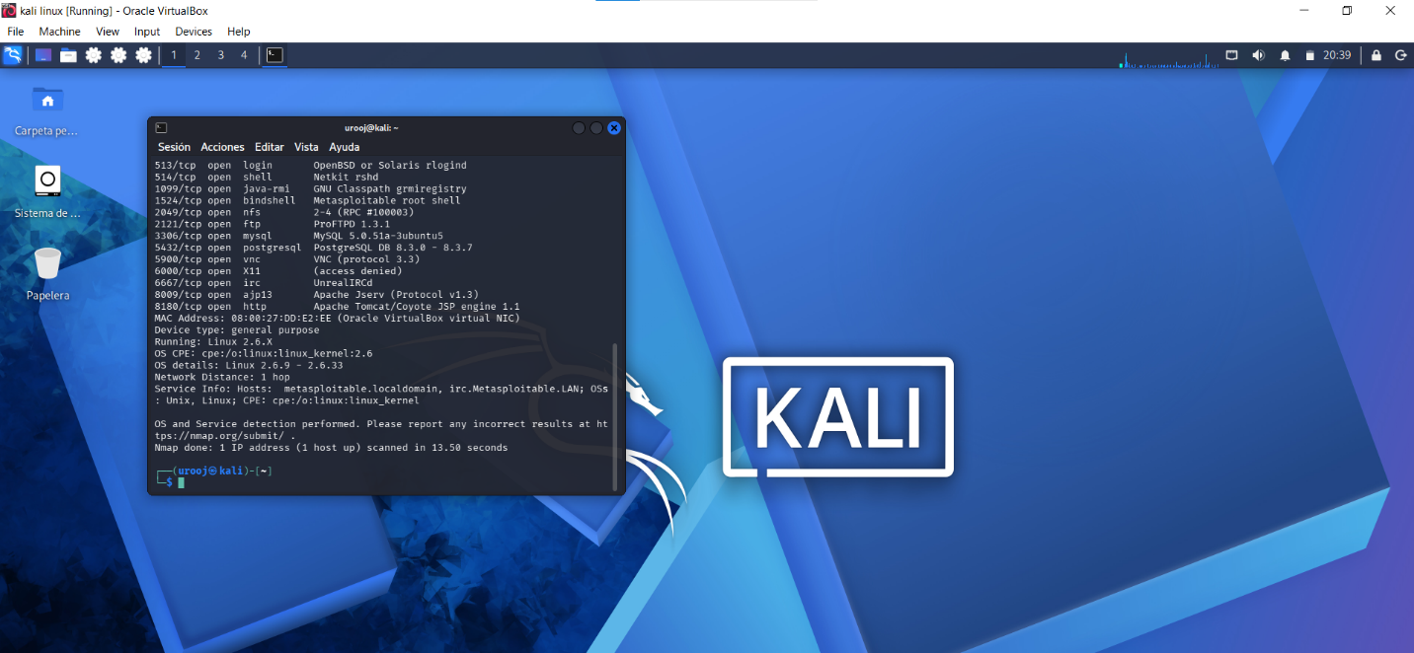]

5. Phase 3: Vulnerability Identification
No exploitation was performed. Vulnerabilities were identified only through banner grabbing.

6. Phase 4: Controlled Validation (Safe Validation Only)
Validation was strictly limited to service version checking via Nmap. No exploit code, brute-force, or payload was executed. This is to ensure ethical and safe testing.

7. Phase 5: Impact and Mitigation
General Mitigation:
1. Update all outdated services to the latest stable version.
2. Close unnecessary ports like 3306 and 5432 from public access using firewall.
3. Implement strong password policy and key-based authentication for SSH.

8. DAY 16: RISK ASSESSMENT

No. Issue Found Severity Business Impact Technical Impact Evidence
1 FTP Service - Port 21 (vsftpd 2.3.4) Critical Complete data theft, loss of customer trust, reputational damage Potential Remote Code Execution, unauthorized file access Nmap scan showing 21/tcp open vsftpd 2.3.4
2 Web Server - Port 80 (Apache Tomcat) Medium Website defacement, phishing risk Information disclosure, outdated service exploitation Nmap scan showing 80/tcp open http
3 Database Services - Port 3306, 5432 High Entire customer database leakage, legal and compliance issues Data breach, data manipulation Nmap scan showing 3306/mysql and 5432/postgresql open
4 SSH Service - Port 22 Low Risk of server compromise if weak credentials used Unauthorized server access via brute-force Nmap scan showing 22/tcp open ssh

Declaration: All testing was conducted in a Host-Only isolated lab environment. No exploitation was performed on any live system.

-۔

